Adult Education Group – Silver Jewellery and Stained Glass
The group
2 groups from the Edinburgh City Council Adult Education Programme taking part in a ten-week programme - Silver Jewellery Making and Stained Glass (intermediate). These are two separate groups meeting in the same large room at the same time, each with their own tutor. The group is made up mainly of retired adults and many of the participants were continuing from previous sessions moving from introductory to intermediate skill level, although there were some new participants. Learners mainly worked on their own projects supported by the tutor on a one to one basis. The group also appeared to support each other in their projects and share ideas and expertise.
Aim of the session
The aim of the session with this group was to gather views on consultation, past experience and viewpoint about the best way to consult with learners to inform future planning and consultation.
To try out an innovative method of consulting with learners and to gain some feedback on their feelings about the method used.
Method
Individual semi structured interview
A series of question were asked on a one to one basis, answers were recorded using a smart pen to ensure that the responses were accurately represented. (The idea behind this was to cause as little disruption to the group as possible! The interviewee could continue working on their project while the interview was taking place.

Participants were interviewed individually, using a script for questions to ensure that there was a consistency, however, additional questions were asked if the interview raised points that were relevant.

Introduction
Background and information on the enquiry was shared with the participants at the start of the session. An explanation on the use of the smart pen was given and permission sought to record the session to take notes for writing up at a later date. Assurances were given that the recordings would be destroyed at the end of the project.

Individual semi structured interview
Questions
- Have you been asked your views on your learning in the past?
  - If yes, how was this done? Did you get any feedback?
  - If no, would you like to have been asked your views?
- What comes to mind when you think of your learning?
- What do you think about the way you were consulted?
- What is the best way to involve you in planning process (why do you think you should be involved)
- What can be done to improve access to learning in Edinburgh (what prevents people getting involved)?

- Would you mind answering a question on the postcard and handing it back for a little more information?

Answers on the postcard Magic wand question - If you could wave a magic wand tomorrow, what would you wish be for adult learning?
Each person in the group was given a postcard with a visioning question on it and asked to complete it. This provided an opportunity to think without limitations, about their vision for adult learning. If there were no limitations, what would their wish be for adult learning?
The postcard was left with the learner after the interview and they were asked if they wouldn’t mind completing it and handing it in at the end of the session.

Resources
Timings
The Results
Participants were very accommodating and supportive of the investigation and answered all the questions posed to them.
Most of the group were interviewed, but due to the amount of learners it was not possible to interview everybody before the session came to an end came to an end. A large amount of data was recorded from the interviews to be collated after the session.

What impact might this activity have on the organisation involved?
Information gained from the semi structured interviews and the postcards, may be helpful for the organisation for future planning and organisation of their programme. Changes may be considered as a result to the feedback, which may lead to improved service to learners.
What impact might this have on local or national planning for adult learning?
This very localised investigation may highlight some issues for consideration in future planning of similar courses.
How are expectations generated through engagement managed after meeting the group?
The group are aware the information gained from this meeting will be available to Edinburgh City Council to help inform future planning. Also that the final report from New Approaches to Gathering Learners Views will be available to the group should they wish it and they will be informed of any future events arising from the investigation.
Reflection on /evaluation of method
2 Groups from the Adult Education Programme – Stained Glass intermediate and Silver Jewellery Making
Both Groups meet at the same time and in the same room, although they work on completely different subjects. It was important not to take too much time from the activity, so instead of writing down the answers they were recorded so they could continue on with their project while the interview was being carried out. Some did, but most took a break from what they were doing to take part. One to one interviews were carried out with each participant where they were working. Each participant was asked if they minded taking part in the investigation after a brief explanation was given about the project and permission was sought to record them using a Live Scribe smart pen to minimise disruption and to gather the data. This was a useful way of carrying out the investigation as it did not distract from the learning too much. Respondents seemed content to answer the question and be recorded for the purpose of the investigation.
The semi-structured interview carried out with the adult learning programme participants was a successful method of gathering the learner’s views. Everybody participated in the interviews and it caused minimum disruption to the group. Because of the numbers and the time it took for each interview, it was only possible to interview 13 of the participants out of 15 attending.
While this was an effective method of gathering learner’s views, it was very time consuming both during the interviews and afterwards at the writing up stage. It did however provide very accurate recording of learner’s views. If a smart pen is not available, it would be possible to write the answers or to record them by some other means.
The postcards were a very effective method of consultation for gathering a quick answer to a question. There was a high rate of return, which provided some useful additional data.

What the learners said about their learning:

Magic Wand Question
‘If you could wave a magic wand tomorrow, what would your wish be for adult learning?’
The postcard responses have now been represented as a Word Cloud, giving a visual representation of all four groups’ views.

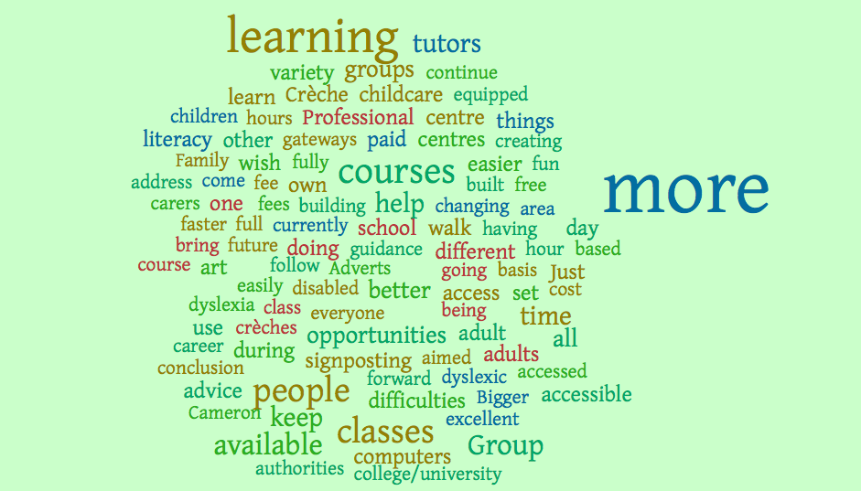

The Word Cloud featured the responses from the answers on the postcard. The most repeated words appear larger.

Semi structured interview responses.
- Have you been asked your views on your learning in the past?
Just over half of the respondents had previously been asked their views on their learning. Of those who had been asked their views, most had been asked via questionnaire, with a mix of electronic and paper based methods.
A number of the respondents mentioned that they received no feedback and were unclear of what the result of the questionnaire had been. There was an interest in receiving feedback on the outcome of the consultation. Other methods used were focus groups. It was raised that there is a difficulty with engagement in online methods with a feeling that it was only the very motivated or disillusioned that would participate. There was also an issue of accessibility to everyone, as a number of learners, particularly the elderly may not have access to the internet. The issue of anonymity was also raised, with the fear that respondents may not say what they think if they felt they could be identified. Of those who had not been asked their views, some felt that online methods would be useful, while others felt that online only methods may result in a limited return. It was also felt that timing was important when seeking views. Often feedback sheets were given at the end of a session when learners had limited time to do it justice.
- What comes to mind when you think of your learning?
There were a number of things that came to mind when thinking about learning, learning a new skill and enjoying learning came out top of the list. The importance of the social side to learning also featured strongly. One lifelong learner was keen to impress that it is never too late to learn, as at the age of 78 she is still learning new things. A number of learners used the skills that they learned at the class to create things at home. As both of these groups were creative groups, they enjoyed making things for themselves and having protected time, was something that learners valued.
- What do you think about the way you were consulted?
When asked their views on how they had been consulted at this session, a number of learners felt that the one to one consultation works well and they also liked the postcard idea as an easy way to gather views. There was a comment however that we were gathering views of people who were already involved in learning and that it would be useful to find a way of hearing from people who were not involved and identify barriers to learning that stop their getting involvement. The respondents recognise learning is a partnership between the tutor and learners and valued the tutor asking them what they wanted to learn at the beginning of the session. There was a feeling that that they could input their own ideas. There is a culture of co-operative learning in the groups, with learners helping each other and not just relying on the tutor. The tutor is accessible and learners have her email address so they can ask questions in between classes. There is recognition about the importance of consultation and feeding into the planning process.
- What is the best way to involve you in planning process (why do you think you should be involved) need to have
A number of learners felt that the best way to involve them in the planning process is to consult on a one to one, although, questionnaires may be effective in some cases and phoning would not be a useful way. Better venues would be something that would help access. The group consulted had been moved to the current premises, which is not as suitable as the one they were in previously. An opportunity to speak to other learners who had already attended the classes may be a useful way to encourage others. Information online is easily accessed, but a number of learners felt that it was not clear when the information would be available. Not everyone has access to the Internet, so it would be important to have it available in a variety of formats. There was a view that Survey Monkey had limited reach. It was felt that barriers include availability of crèches and cost. These factors may prevent potential learners getting involved.
- Would you be interested in using social media e.g. Facebook to communicate?
There was a feeling that learning for pleasure would require different methods to learning for work. There were a number of frustrations around the process of class numbers and having to wait until the class was due to start before confirmation that it would run, leaving no time to arrange an alternative. It was felt that Edinburgh had good access to adult leaning for adults. Some felt that Facebook was felt to be a, good medium for some if they already use it. It may have a use for posting pictures of what can be achieved in the class. However as access to the internet and Facebook is not available to everyone and some are unsure about privacy issues. It is something that may not work for all. Some would be interested in a closed group for stained glass, rather than a general learners Facebook page.
Conclusion
The face-to-face semi structured interviews was a successful way to gather learners views, however it was time consuming both in carrying out the interviews and in writing up the data. It was however very accurate, as the interviewer could listen to the interview again and check out what was said. It was also not open to interpretation or bias from the interviewer as the recording was transcribed with the learner’s own words.

There was a high degree of engagement from group members in both the interviews and the postcards, which generated a large amount of data.

