Book Talk Group
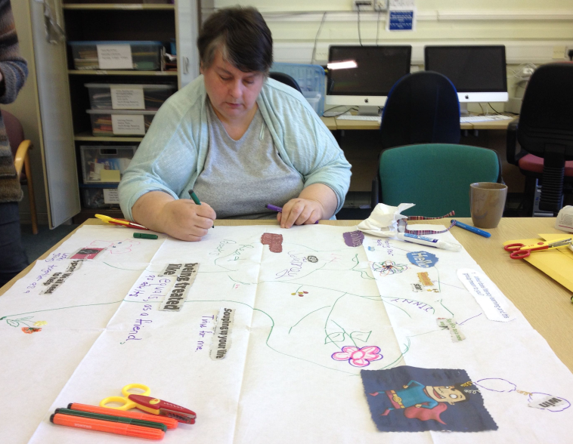
The group
The Book Talk Group meets on a Thursday morning in South Bridge Resource Centre. It is principally a literacy group who meet once a week. Individuals work mainly on a one to one, with occasional group work. Two volunteer tutors support the paid tutor. Four learners attended the group on the day of our session, some learners were unable to attend. A number of the learners also attend other adult learning groups in addition to the Book Talk Group.
Aim of the session
The session was designed to gather learner’s views on their experience of consultation and what they consider to be the best method to do this. Exploring a variety of methodologies to find creative ways to engage with learners, hearing their views on the experience of taking part in learning and finding out from learners about their view of the consultation methods used.
Method
Prior to attending the group, communication was made with the group tutor to find out about the group and the methodology was designed around them, based on this knowledge. A number of methods of interaction were used to engage with the group and consult with them on their views. The group had agreed to take part in the activity for the duration of the session, as they recognised that what they were taking part in was also learning and as a result, they were interested in the session. The discussion was recorded using a smart pen for the purposes of accurate reporting. When the report is complete, the recordings will be deleted.
Methods
- Free Word Association – the purpose of this activity was to act as an icebreaker and get the learners thinking about learning. It was also hoped that the words would act as a prompt for the exercise that was to follow. The words were recorded on a flip chart to provide words and spellings for the learners, should they wish to use them.
The words were: words/learners/listening/literacy/confidence/literacies/education/achievement/goals/fun

- Voxur Box - Voxur is a computer with a build in camera and lighting inside a suitcase. Questions are preloaded and act as a video diary room. It is a mobile way of engaging with people without them having to write. Learners had the opportunity to try the video diary while the rest of the group were engaged on the creative activity.
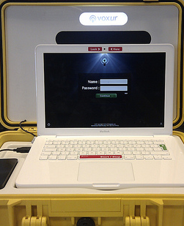

- Let’s Get Creative Consultation Collage – this exercise was designed to explore a methodology for consultation with learners that allowed them an opportunity to explore a number of questions in a creative non-threatening way. The activity was designed specifically for literacy learners, but could also be adapted as a group exercise on understanding the written word and critical literacy.
The group was split into two with each one given a question to explore and answer using the materials provided.
Question 1 - What does literacy learning and this group mean to you?
Question 2 - What is the best way for you to have your say about learning opportunities e.g. on what is available and how it can be improved?
Each group was given a different question and 30 minutes to make a collage, which answers the question, using the equipment provided. Two large sheets (in this case, two paper tablecloths) with a question at the top of each sheet were provided. The group were asked if they are happy to work in small groups and answer one question each. They could write/draw/doodle/create or use words or pictures cut out of newspaper in order to answer the question. Support was also available from the tutor during the session.
Once complete, each group shared their collage and talked through their interpretation of their answer. The result was a visual representation of the question.

4. Concluding Discussion – whole group round the table were asked a number of questions.
- Have you been asked your views on your learning in the past?
  - If yes, how was this done? Did you get any feedback?
  - If no, would you like to have been asked your views?
- How much say do you have in planning the group?
- What can be done to improve access to learning in Edinburgh (what prevents people getting involved)?
- Would you be interested in the establishment of a learner’s page on Facebook for you to communicate with other learners?
- What do you think about the way you were consulted today?
5. Answers on the postcard Magic wand question - If you could wave a magic wand tomorrow, what would you wish be for adult learning?
Each person in the group was given a postcard with a visioning question on it and asked to complete it. This provided an opportunity to think without limitations, about their vision for adult learning. If there were no answers, what would their wish be for adult learning?
Resources
- Flip charts or paper tablecloths
- Fruit smelling pens
- Biscuits/fruit
- Newspaper/magazines/creative bits and bobs, glue stick craft scissors
- iPhone - photo permission slips
- Voxur
- Postcards
- Livescribe Echo smart pen
Timings
The group had agreed to take part in the activity for the duration of the session, which was two hours.
The timing could be reduced by carrying out only one or two of the above activities.
The Results
The session provided information from learners about how they have been consulted in the past and how they would like to be consulted in the future. The learners enjoyed working on something different, but also recognised that it was still learning. The session was very full, but it was also varied and the opportunity to work in smaller groups, allowed the learners to find their voice through creativity during the ‘Creative Consultation Collage. The result of this exercise was to provide a visual representation of their answer to the question posed.
The Voxur worked well with the learner who took part in this method, however due to technical difficulties it was not possible to use this methodology with the second learner who had agreed to do it. However, a useful discussion was held on the use of this methodology and while the group felt it was an interesting method, although they were not keen to use it. They did however feel that the methodology would work better in a different context.
There was 100% completion of the postcards, reflecting their wishes for adult learning
What impact might this activity have on the organisation involved?
The organisation may be interested in the concerns of learners for their provision and the uncertainty that this causes for the learners.
What impact might this have on local or national planning for adult learning?
Planners may wish to consider some of the learners’ feedback when organising provision in the future. This session identified some of the things that worked well in the provision that was visited and may provide some useful points to consider when planning future. It may also raise the effect of perceived uncertainty of funding for provision and the need to communicate to learners around budget cuts.
How are expectations generated through engagement managed after meeting the group?
Prior to the session the group were informed about what was planned and as at the start of the session they were consulted about whether they were content to take part. One theme that came from the discussions with the group was the importance of feedback to the learners. Although they had taken part in a number of consultations in a variety of different contexts, it was rare for the learners to receive feedback after the consultation was complete, or on any actions that were taken as a result of the consultation. However the learners recognise that the book group has a positive culture of listening to learners and negotiation about the work that they do! The learners were informed that the group would be sent a copy of the information gathered from the visit, prior to completion of the final report on New Approaches to Gathering Learners Views.
Reflection on /evaluation of method
This session was packed with different methods for the purpose of gathering learner’s views on what the best methods of engaging with learners and hearing their views. Normally all of these methods would not be used at once, however there can be a benefit to using a number of different methods, as each can bring up different issues and information and can be a useful tool for clarification of views. Although in this instance a smart pen was used to record the session, there are other ways to do this, depending on the time available for analysis. Transcribing the recorded data can be time consuming and requires time to bring it together into a useful conclusion. If written recording is to be used without the back up of an audio recording, it may sometimes be useful to have the assistance of a second person scribe the information. This will allow the facilitator to concentrate on the interaction with the group and ensure that information is not missed.
In this session an introductory activity, (free word association) was used to ease the group into the session. This was useful as to launch into the main activity straightaway may lead to different levels of engagement. This icebreaker was not too challenging, but introduced the group to some of the areas that would be discussed later in a non- threatening way. It was also recognized as a fun activity. The group liked the word association activity because they don’t have to put too much thought into it. The icebreaker was successful in creating words that could be used for the next activity although they didn’t use it that way.
The creative consultation collage was a really effective method for giving learners, particularly literacy learners, time to think about and discuss the issue that they were being consulted on. It requires a number of resources, but these can be varied depending on what is available and is only limited by imagination. While carrying out this activity, refreshments were made available, helping to make the make the environment comfortable for the learners. In this situation there were two groups working on two questions separately, although it would work well with more groups either with additional questions, or two different groups working on the same questions. If there were more learners, the results would have been interesting to compare the differences and similarities. Other variation could be achieved by providing different resources. Asking the learners to explain the collage to the other group was an important part of the activity and learners fed back that they enjoyed creating the collage. This activity provided a good visual image in answer to the questions.
The Voxur is an interesting method of consultation that puts the learner in control, however in this instance, it had limited success. The learner who used the Voxur found it interesting, although requested the facilitator to help work the equipment. The second learner was quite happy when there were technical difficulties and she didn’t have to use it. In the discussion afterwards, learners could see an application for the Voxur, but felt they would be too self-conscious to use it. Learners felt that it would be useful for practicing interview skills, but that it may appeal more to young people. Others were interested in knowing what it was for and agreed it would be good if it was used for an educational tool, e.g. collecting evidence. The Voxur would be useful in contexts where there is an opportunity to use recorded visual images as part of the reporting method. Learners were very positive about the group, “there is always somebody around if you need help and we are not embarrassed to ask for help”. Also it was recognised that learners’ were happy to help other learners in the group.
The semi structured concluding discussion, was a good way to round off the session and provided useful supplementary information about their experience of the consultation. It provided a space for learners to reflect on their experience of learning, concluding “you always learn something every day, if you don’t go out you don’t learn”.
What the learners said about their learning:

Postcard Magic Wand Question ‘If you could wave a magic wand tomorrow, what would your wish be for adult learning?
The postcard responses have now been represented as a Word Cloud, giving a visual representation of all four groups’ views. The words repeated most in the responses appear larger.
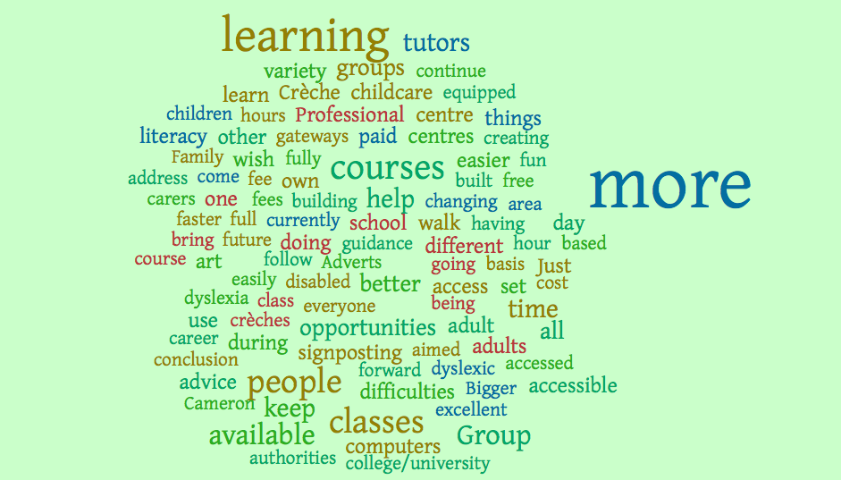

Free Word Association responses
Morning another day, kettle, breakfast, oh no
Words dictionary, read, write
Learners smart, helping, intelligent, helping, group
Listening music, talking, ears
Literacy books, encyclopaedia, dictionary
Confidence happy, paper, writing
Literacies writing, emotion, IT, don’t know what it means (a brief explanation was given on the difference between literacy and literacies
Education learning, school, teachers
Achievement happy, prize, great
Goals tennis, football, achievement
Fun fair, play, card making, good laugh
Views mountains, thoughts, opinions, TV
The responses to the free word association help to demonstrate the importance of being clear about language and what is meant by the words that are being used. For clarity it is important to ensure that everybody understands the meaning of the words in the context they are being used.
Learner feedback Liked the word association, don’t have to put too much thought it is a good icebreaker. Created words that could be used for the following activity although they didn’t use it that way different, enjoyable fun to do!
Voxur Box answers
Question | Answer
What involvement have you had in adult learning? | I go to a class on a Monday and a Wednesday for computers as well as this group on a Thursday
What do you enjoy most about coming to the literacy group | Learning things
What much say do you have in what you learn? | When you are in class you get your say anyway
How were you asked about what you want to learn? | They ask you what thing you wanted to do, then you pick it and then you do it!
Do you think there is a better way to hear about your views? | We do fine and we all help each other in the class
What do you think is the best way to involve you in making decisions about your learning? | You are better asking and then you will get somewhere then

Voxur discussion– it was good, something different. Happy when it didn’t work it wouldn’t be something that I would be interested in too self-conscious. Others interested in knowing, what it was for it would be good it was used for an educational tool, e.g. collecting evidence it may appeal more to younger people it would be good for practicing interviewing skills. There are possibilities, but a lot of reservations.

Creative Consultation Collage
Group 1 question - What does literacy learning and this group mean to you?
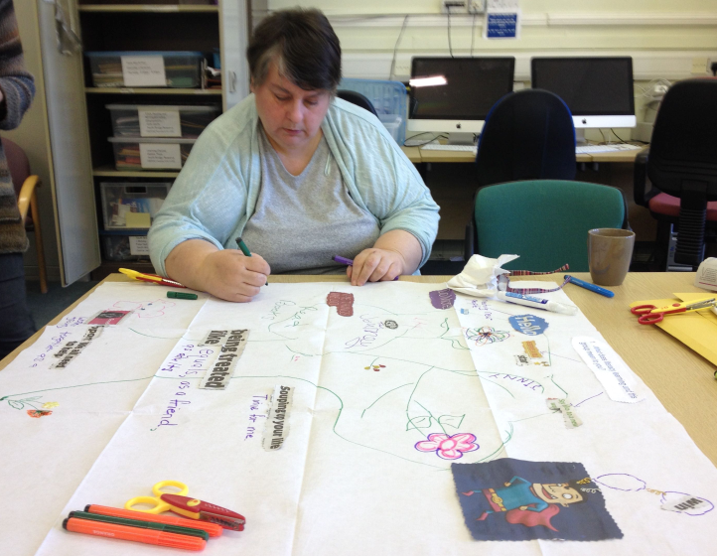
What the picture represents:
Superhero picture with win win caption!
Being treated like equals as a friend and as an adult!
Little dog - we all need to help support, working together in a group.
The things we do – read books, worksheets, work on computers
Tree and flowers – because it is all about growth, everybody grows when they come here! Also represents the tree of knowledge.
Thought bubbles because it gets you thinking, we do a lot of thinking in the group
Star - deserves a gold!
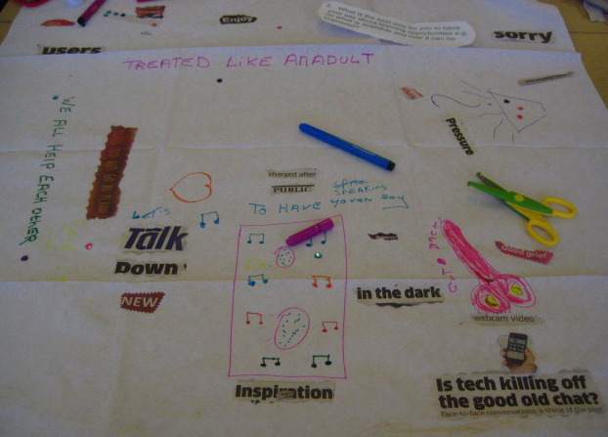
Group 2 - What is the best way for you to have your say about learning opportunities e.g. on what is available and how it can be improved?

What the picture represents:
Tree like man drawing - John
Cut backs - In the dark - reflecting the uncertainty that exists with budget cuts, also the drawing of the pair of scissors, which depicts the cuts
This brought out a discussion on what the learners were doing to raise the profile of the benefits to being involved with the group. Spoken with politicians, councillors and MP’s, letter writing campaign budget campaign
Opportunities - we have a speaker saying have your say!
Let’s talk tree!
How did you feel about doing the collage?
Good, it was learning, but also fun as well. Fun, pretty good, different from what we normally do in the class. Helps because you are writing and there is group input, everybody has a little input. It is something different although you are still learning.
Good activity for getting discussion going in a non-threatening way.
Did you have any difficulty finding the words?
Found the words easily and were able to associate with them! They just jumped out at me.
Concluding discussion
- Have you been asked your views on your learning in the past?
  - If yes, how was this done? Did you get any feedback?
  - If no, would you like to have been asked your views?
Responses:
Yes, we have answered questions on sheets.
I have been involved in other learning situations, this is different though!
When I was younger I was embarrassed about it, now that I am older I have stopped being embarrassed about it I think when you go to do something about it you get more confident.
Don’t think we got any feedback
As well as filling in individual sheets may be good to discuss it first. Use sticky notes
Do it as group – sometimes people do their own sheet, but don’t really speak up. I think it might help other people to be encouraged maybe do a group exercise before filling in their own forms.
Give a worksheet – we get a choice in what we do, I tell them what I want to do!

- How much say do you have in planning the group?
Responses:
A lot, most of the say we choose asked what we would like to do and what our opinions are about what we would like to do next. Still do personal learning plans and how you feel post its. Not enough advertising and they keep changing the names Big Plus need to try to keep it as one name so people can find what they want – stop Fiddling it isn’t easy to get information, there is not enough information
They just leave me, because I have not been there long I just keep quiet
Happy with the way things work in this group.
It would be good if we used flip chart sheet, about how people feel about how they have got on discussed every now and then, maybe at the end of term good to do something different!
- What can be done to improve access to learning in Edinburgh (what prevents people getting involved)?
Response:
Stop changing the name!
- What do you think about the way you were consulted today?
Responses:
Collage made you think about what you are wanting out of the class and what you are doing. It was useful and fun enjoyable and fun to do. I liked the funny scissors, the artistic side is quite important don’t do enough of it to bring this out! Good visual message
Get a lot out of the group, there is always somebody around if you need help and we are not embarrassed to ask for help. Learner to learner, didn’t feel like it was childlike and recognized that it was all literacy!
In future, it would be good if we used flip chart sheet, about how people feel about how they have got on discussed every now and then, maybe at the end of term, good to do something different!
- Would you be interested in the establishment of a learner’s page on Facebook for you to communicate with other learners?
Responses:
Learners page anything bar Facebook, don’t know if I would want to discuss it on Face Book. May be okay if it is a private page, not connected to main Facebook. It might be good to talk to learners from other areas

