Numeracy Group
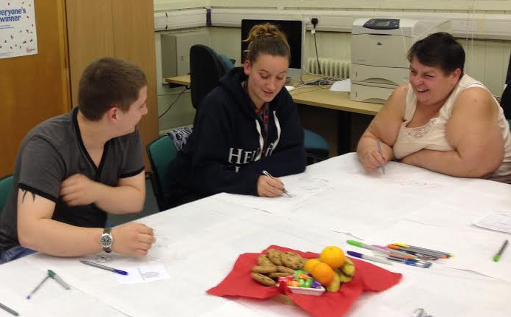
The group
Numeracy Group, advertised as Tuesday Evening Study Group, meet in the Number Shop in Edinburgh. The group meet on a Tuesday from 18:30m-20:30. A tutor and two volunteer tutors support the group, working with individual learning plans (ILP) to their own priorities and interests around numeracy. The group consists of a mix of ages and learners mainly work individually.
Aim of the session
The aim is to explore methods of consultation with learners to gather their views on the best way to find out about their involvement in learning and to try out a variety of methodologies and gather learner’s views on the effectiveness of each, identifying preferred methods of consultation.
Method
The method of engagement used for this group was inspired by some of the elements of ‘World Café’ discussion methodology, using a number of questions set in advance. Additional supplementary questions were asked as a result of the interaction with the group. This session was based around some of the principles important to “World Café’ methodology including setting up a comfortable environment, where participants feel relaxed and at ease, to contribute their views freely.
This involved setting up a café style environment and to do this the table were covered with paper tablecloths, with some refreshments, in this case biscuits, fruit and some coloured sweets, the group also had access to tea and coffee. Coloured pens were placed in the middle of the table. This was very different from the usual set up of the room and acted as a bit of a conversation starter, the group normally sits at two separate table spaces.
Communication in was had with the tutor, to find out about the group and identify a suitable methodology. Information was sent to the group in advance so they knew what was involved in the investigation. The group was consulted, by the tutor, in advance to check whether they were happy to be involved.
The session started with introductions and an explanation of the process. It was explained that the conversation was being recorded using a Smart Pen and that data would be used for the purpose of the final report of “New Approaches to Gathering Learners Views”. It was explained that they would have an opportunity to see information from the session prior to publication of the report in order to check whether they were content with the content.
The group was encouraged to write, draw or doodle on the paper with the coloured pens to capture any additional data. An initial question was posed to get people talking and comfortable with the setting. – ‘What brought you in to adult learning?’ The session then continued using the prepared questions and additional questions added as a result of the discussion!
The questions used were:
- Would it be easier with somebody you knew to answer these questions?
- Can you think of any other way people could consult with you?
- Why is it important for learner’s views to be head?
- What comes to mind when you think about your learning?
- What do you get out of being part of a learning culture?
- How would we get your views to those responsible for planning?
- How did you find out?
- Any other ways
- What previous involvement have you had in learning?
- From your previous experience in your groups how were you asked your view?
- What about questionnaires, do they get you to fill out evaluation forms?
- How would you prefer to be asked your views?
- Did you ever get any feedback about what had happened as a result?
- What do you think about the way you are consulted today?
Resources
- Flip charts or paper tablecloths
- Fruit smelling pens
- Biscuits/fruit
- Livescribe Echo smart pen
Timings
The group took part in the activity for the duration of the session, which was two hours.
The Results
The group engaged well in the process and although the agreed time for the discussion was 20 minutes, it actually took longer. I had planned to have the consultation at the second half of the session, however it was requested that the session was carried out at the beginning of the session until the break. The group were enjoying the discussion in the group that they decided to stay in the group for the rest of the session and continued to chat about their learning. Although this was unintended and unplanned, I did not feel that the time was wasted as it was the learners’ decision to continue on, however in future I would limit the time for discussion to limit interruption to the learning session.
There was good engagement with the postcards and some good discussion recorded on the pen. Limited writing on the tablecloths, but a lot of doodles and drawings,
What impact might this activity have on the organisation involved?
The information from the learners will be fed back to the organisation and could inform future planning. I felt that the learners appreciated joining up for conversation about the learning. It may be useful to negotiate some more joint work in future if there are common areas, or even discuss once a month have a group discussion about their learning and share ideas for future work.
What impact might this have on local or national planning for adult learning?
This information will form part of the report on Gathering Learners Views and it may inform future consultation.
How are expectations generated through engagement managed after meeting the group?
The data will be sent to the group (perhaps visit to discuss) prior to appearing in the report New Approaches to Gathering Learners’ Views.
Reflection on /evaluation of method
The ‘World Café’ inspired approach worked well with this group. The idea was to make it a comfortable as possible to help participants to contribute their views freely. Setting the scene was important to the interaction, paper tablecloths coloured pens and refreshments helped to make this a very different environment. The group seemed to feel at ease and seemed to enjoy the opportunity to talk about their learning. The session was originally planned for the second half of the session so that the learners could do some of their normal activity, however this was changed to the first half of the session at the request of the tutor. This actually helped by allowing the opportunity to have the room set up before the learners arrived, which had more impact. The session was completed as planned before the break, however the learners decided that they wanted to continue the discussions. The discussion continued after the break and with permission it was recorded and added to the data. It was the group decision to continue with the session and could see the value in it.
The postcards and photo permission forms were distributed to the group and they were asked if they would complete them. There was 100% response rate to both. The data from the postcards will be added to the data from the other 3 groups and a word cloud created from the results. This will highlight the commonalities between the groups, as repeated words appear larger. It will also represent the themes that appear in the answers.
This session represented good engagement with the postcards and some good discussion in answer to the questions, which were recorded on the pen. There was limited writing on the tablecloths, but a lot of doodles and drawings.

What the learners said about their learning:
The postcard responses have now been represented as a Word Cloud, giving a visual representation of all four groups’ views.
Magic Wand Question
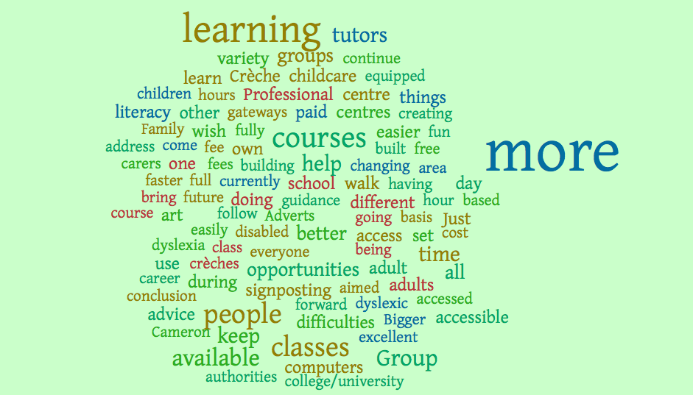
‘If you could wave a magic wand tomorrow, what would your wish be for adult learning?

The Word Cloud features the responses gathered from the answers on the postcard activity. The words that are repeated most often appear larger in the Word Cloud.
Response to the questions:
1 What previous involvement have you had in learning?
Book club, writing, read books and do forms and stuff.
Others went to other learning
2 From your previous experience in your groups how were you asked your view?
They just asked you if you understood it and if not they would explain it more thoroughly on a one to one rather than the whole class
3 What about questionnaires, do they get you to fill out evaluation forms?
We do plans and we write at the end of the course to see how we have got on towards our goal
4 How would you prefer to be asked your views?
I think it is better to learn something and then do a mini test to see whether you have learned it a bit like we do in maths.
Like to test knowledge to see what we have learned. It’s quite good when you have got a memory like a sieve it is good to find out what you have learned and then get a chance to learn anything you don’t know!
5 Did you ever get any feedback about what had happened as a result?
I went to college and I kind of failed and I panicked and I didn’t go back. I got upset and didn’t ask, nobody got in touch and I didn’t carry it on. I panicked and thought that was, it I am not good enough. It would have been good if someone had phoned and asked why I had dropped out. I felt that my reading wasn’t that good and the computer test threw me a bit, as I didn’t understand the questions, although they said I was ready for sitting it. I think because you are stuck to a time and you only have so long to do it and because I couldn’t do it I gave up. I was asked if I was ready and I thought I was ready, but obviously not.
6 What do you think about the way you are consulted today?
Good, it just feels like we are having a discussion it doesn’t feel like you are shining a light on me saying answer this the best way you can?
Not nervous!
7 would it be easier with somebody you knew to answer these questions?
No, probably yes and no, when it is someone you don’t know you probably don’t want to talk as much. It’s like being camera shy they may not want to talk as much and keep to yourself. If it is somebody you do know, because you’re open and you know them and they pay more attention if you are camera shy and don’t want to open up, you just keep to yourself.
College was last learning, it was quite rushed and if you don’t manage it in the time you don’t get a chance to go back because there is so much to do in the time. It is different in the math’s group, you can actually go back and do it.
If you get stuck there is someone there, you can learn at your own pace.
I know we are a busy class, but there are a few tutors and you can get help on a one to one, you sit and wait and you will get help when they are finished with somebody else. You can ask any of the tutors and they all seem to know your level and what everybody is doing.
Get more help here with my math’s, than I did at high school, because there was only one teacher helping us I never really learned as much because all we done was given a worksheet and told to fill it in.
In this group they are more patient and understanding of everyone’s needs, if you can’t do anything they will help you. We help each other in the group, if we don’t know something and they do they help us and we work together. It’s helpful to have people with different opinions and different ways of working things out. If you do not understand things, one of the other tutors may have a different idea. Everyone does have a different learning style, if you don’t know how to do it one way, someone else may have a different way to learn that may work for you. You can try their way and then you have found another way of learning.
Volunteer is a learner too, just gone through accreditation
Tutors and volunteers work as a team
Every day is a learning day
Writing on tablecloth is fun!
8 Can you think of any other way people could consult with you?
We have a review at the end of the night, what we have been doing and what we have been working on, how we feel. It is filled into the learning plan tutor by the tutor. If we don’t finish, we write down that’s what I want to do next week.
How would you feel about using video box?
Not keen, prefer the way they are doing it with the discussion. Not keen on questionnaires prefer talking to someone one on one, because sometimes questions are written in a way that I don’t understand it and I need to get someone to explain (dumb it down) and what they are asking of me then I will be able to answer it.
Sometimes questionnaires are complicated, I just put N/A half the time.
Everyone has their own interpretation of what is meant.
It is like when you send text messages and they take it the wrong way you have to explain that that I not what I meant by that so need to phone them up and explain so consultation by text wouldn’t work.
Facebook – probably be okay and then I can store them away for future projects Facebook quite good, everyone has an opinion and they always put their opinion on social media so it probably would be a good way to go if it was a closed group invite only. Would be happy to open it to other learners of similar capabilities.
School has Facebook only for invited mums, we lose that when he moves to high school. It’s like parents council, you get information on what is happening in the school, you can ask questions and put information on it as long as it is appropriate. Facebook page and you get added. It helps to keep you in touch with what is going on.
9 Why is it important for learner’s views to be head? We are the ones that are leaning. Because if we are unhappy about something it could be changed and dealt with to help them to learn better rather than keeping your mouth shut and not learning.
Learner’s views should be heard to help make learning better.
10 What comes to mind when you think about your learning?
I wish I was a bit quicker at picking things up and that they would stay in my head.
What’s your strength and weaknesses, a lot of people have a lot of strengths and some other people have weaknesses. I feel I had, I am doing English and arithmetic, when I first started my learning, I wouldn’t say that the strength was there, but I am heading in the right direction. Sometimes feel that because I am juggling both, sometimes my strength goes to my English and sometimes when I have a week with a gap them my strength goes to my arithmetic. I don’t know if that’s how your brain works, people’s brains work differently.
11 What do you get out of being part of a learning culture?
That it is okay to make mistakes that are how you learn. Everything has to be perfect for me, if I get it wrong I freak out, but I am learning that it is okay to make mistakes. You won’t be rushed while you are here, in school and college you do feel rushed because you have to get it done by a deadline, but here, you can take your time once the pressure is off, it is easier to learn. Nobody’s breathing down your neck. Small group makes a difference you actually get a chance to get helped rather than being in a class with everybody screaming for help.
12 How would we get your views to those responsible for planning?
By telling somebody, budget course in Leith Community Centre and we are going to be writing to councils and maps LCD to find out what they are cutting back and why. An MP is coming to the group and we have got a questionnaire for him, we have questions to ask him.
Is feedback important – went to WEA one at Riddles Court
Stop changing names! People don’t realize with the name change it can be confusing may put somebody off! People don’t know how to find out about opportunities. It needs to be explained a bit more particularly for people like me with dyslexia who find it hard to read big words, which I don’t understand if they broke it down into what it actually meant or found something else making it simple people would have more of a chance of coming forward.
13 How did you find out?
College contacted them to ask about math because I needed it for joinery, was told we can’t help, but we can refer place that can.
The library, I don’t have the Internet it’s not everybody that can afford a laptop or computer. They are talking about closing the library, where they run classes, that is why we have the budget club to talk about things like this. They have shut the community centre down. The library is an important building, for making information more accessible.
Math’s is triggered off by employment at the minute, job entre are identifying that people are needing help with core skills, they have to be seen to be improving, sometimes people come along when they don’t really want to be there, but they have to attend. Often if they come along twice they might stay and come along for the right reasons. Sometimes people don’t realize that they need help with math. Motivation is important everybody has a reason for attending learning, kids at school, job seeking, college etc.! They need to come for themselves. Taught differently need to teach them how the children are taught so they can understand and help their kids.
14 Any other ways
Group discussion is a really good ways of getting views over 1-1 mixture of 1-1 and individual. You are asking the question and writing down the answer, they don’t have to worry about spelling or writing things down or getting it wrong.
Discussion has been a good way to get views across.
Asking about impact is a good question, ask learners what the impact of their learning has been.
Group discussion gave me more confidence to talk in a group. I don’t actually do group work it is helping you can see what everyone else is doing and that encourages you to think maybe I can do that somewhere down the line. It is a nice social activity, meeting people of all ages, discussion can jog your memory about how it is done.
You are more relaxed, no pressure, go under your own speed go reach your goal, whenever you want. I am certainly not there yet. May always want to go further “does the yellow brick road ever come to an end?”
Feedback is important! The group was told them that they would be getting
Feedback from this meeting prior to publishing the report.
Writing on the tablecloths
A lot of doodles and drawings including smiley faces
Web not always appropriate
Careers advice/advisor at library
Learn from the learners
In it together
Find out best approach for learner and pace
- Face to face good
- Questionnaires boring
- Winds of change
- Thinking out loud
- A team
- Gold
- MySpace is as empty as me!
- Love being in classes
- Favourite quotes “everything happens for a reason”
“In alcohols defence I have done some stupid things sober”
“PMA – positive mental attitude”
“Pay attention and you’ll get a pension”
Summary and reflection
The group engaged well in the process and although the agreed time for the discussion was 20 minutes, it actually took longer. It was planned for the consultation at the second half of the session, however it was requested that the session was carried out at the beginning until the break. The group was enjoying the discussion in the group that they decided to stay together for the rest of the session and continued to chat about their learning. Although this was unintended and unplanned, it was felt that the time was not wasted as it was the learners’ decision to continue on. However in future maybe set a definitive time limit for discussion so that interruption to the learning session is kept to a minimum
There was good engagement with the postcards and some good discussion recorded on the pen. There was limited writing on the tablecloths, but there was some a lot of doodles and drawings,
The ‘World Café’ inspired approach worked well with this group. The idea was to make it a comfortable as possible to help participants to contribute their views freely. Setting the scene was important to the interaction, paper tablecloths coloured pens and refreshments helped to make this a very different environment. The group seemed to feel at ease and seemed to enjoy the opportunity to talk about their learning. Having the room set up before the learners arrived, is important and it was successfully created a different environment from the normal learning session. The session was completed as planned before the break, however the learners decided that they wanted to continue the discussions. The discussion continued after the break and with permission it was recorded and added to the data. It was the group decision to continue with the session and could see the value in it.
The postcards and photo permission forms were distributed to the group and they were asked if they would complete them. There was 100% response rate to both. The data from the postcards will be added to the data from the other 3 groups and a word cloud created from the results. This will highlight the commonalities between the groups, as repeated words appear larger. It also represents the themes that appear in the answers to the question.

