The Learner Journey Road Map
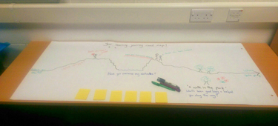
The group
This was a College Community based IT group running in a Community Learning Centre, the group consists of 6 to 12 adult learners, all female, whose ages range from mid twenties to late sixties. Several learners in the group have attended for more than two years, although there are new learners joining all the time too.
Aim of the session
The aim of the session was to give the learners an opportunity to talk about their learning journeys, paying particular attention to any specific barriers that they have managed to overcome and how they achieved that and any specific aspects of their learning that has been particularly useful and conducive to their learning.
Method
A map outlining a starting point, some ups and downs and a finish point is provided as a focus for the discussion activities. The learners are asked a selection of questions and asked to jot down some answers on post it notes and then place them on the map. They are encouraged to discuss their answers with the facilitator and others learners in the group.
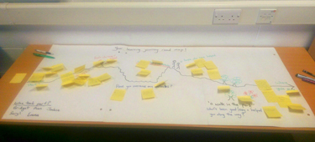
The points on the map the learners were asked to comment on were:
- Where I started (What brought you to this group in the first place?)
- Uphill struggle (Has there been anything that made it difficult for you to learn or to keep attending the group?)
- People who haven’t helped (Has there been anyone who has made it difficult for you to continue with your learning journey?)
- Barriers (Have there been any barriers that might have brought your learning journey to an end?)
- How you overcame them (What did you do /what was put in place that helped you to overcome any barriers you faced?)
- People who have helped (Have there been people who have encouraged you or helped you along?0
- A walk in the park (Could you describe anything that has made learning particularly enjoyable and has really encouraged you to keep going?)
Where you’re going (What are your plans for the future when you finish this course?)
Resources
A map outlining a starting point, some ups and downs and a finish point is provided as a focus for the discussion activities.
Small post-it notes are provided for learners to complete and place on the map.
Timings
The group in this instance completed the activities in 30-40 minutes. In a different group the session could be shortened but could probably not be completed in less than 20 minutes. This method could be adapted into a longer term, sustained feedback tool by having a copy of the learning journey map on the wall in the training room so that learners are free to add their post it notes on an ongoing basis.
The activity could be carried out by an individual but by sharing experiences, the learners start to really engage with the issues that have had an impact on their own journeys and compare barriers and support mechanisms with other learners.
The Results
Five learners took part in the session (L1 – L5). To start with the facilitator talked through the points on the map, explaining what each of the pictorial elements represented. Learners very quickly started to write their thoughts and experiences on the post it notes provided and add them to the relevant section of the map. This created a lively, interactive atmosphere with learners showing an interest in each other’s responses and adding more detail as they went along. The whole session took around 30 – 40 minutes. Over a tea and coffee break afterwards the facilitator asked the learners what they thought of the method and all agreed that it was enjoyable and had really got them thinking and talking about what was important to them about their learning.
What impact might this activity have on the organisation involved?
It might create an opportunity to pass on positive feedback to the members of staff who have played an important part in the learning of students e.g. the positive impact the janitor has had in this centre for at least one learner.
The method highlights what is going well in provision as well as potential areas for development.
The method also raises awareness of the barriers learners have faced.
What impact might this have on local or national planning for adult learning?
The method raises awareness of what is important to learners.
It also raises awareness of the potential barriers to learning and how they can be overcome.
How are expectations generated through engagement managed after meeting the group?
The activity was promoted as a way for learners to share their experiences so that the organisation can learn from what has gone well for them and what elements of their learning have been more challenging. The facilitator explained that a copy of their feedback would be provided to their tutor to pass on to them and also to college management.
Reflection on /evaluation of method
The method seemed to work well as a means to stimulate a rich discussion in a relatively short period of time. There is some overlap between the ‘uphill struggle’ and ‘barriers’ sections and this should perhaps be teased out into minor issues for the uphill struggle section and major barriers, or combine both or leave it as it is so that individual people can interpret them as they wish. This method could be adapted into a longer term, sustained feedback tool by having a copy of the learning journey map on the wall in the training room so that learners are free to add their post it notes on an ongoing basis.
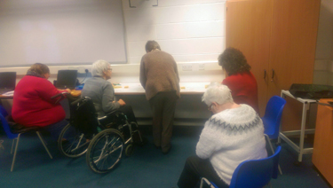

What the learners said about their learning:
- Where I started (What brought you to this group in the first place?)
(1) became unemployed after ill health.
(2) Retired early. I had a PA at work who did all my computer stuff and I wanted to learn how to do it myself.
(3) I had lost my job and, after a few weeks, was asked at the Job Centre if I wanted to do a computer course ‘cos I knew nothing about computers.
(4) Confused about where to start
(5) My daughter gave me her old computer when she got her laptop and I kept phoning her how to work it and she told me to go to classes.
- Uphill struggle (Has there been anything that made it difficult for you to learn or to keep attending the group?)
(1) My memory lets me down sometimes due to Parkinson’s
(2) Sometimes getting into course with wheelchair
(3) Finding the correct course with disabled access etc.
(4) My first class I did not know anything about computers so I thought I would never learn how to use it
(5) Health
(6) Family issues
(7) No transport
(8) Instability … changes in tutors and classes /venue were all unsettling. We had to start at a new venue which was difficult all over again. Some people stopped and didn’t come back.
- People who haven’t helped (Has there been anyone who has made it difficult for you to continue with your learning journey?)
(1) My son saying what was I learning at the computer course because he thought I was not learning anything.
(2) My husband asking why do I want to learn at my age (65)
- Barriers (Have there been any barriers that might have brought your learning journey to an end?)
(1) Sometimes you get stuck and can’t get going then all of a sudden you just sail through it. (2) Travel to new location after the local class closed down.
(3) I still panic when the computer tells you there’s a risk to security!
- How you overcame them (What did you do /what was put in place that helped you to overcome any barriers you faced?
(1) Sometimes it gets hard and I felt I didn’t want to come back but I kept coming to the course to learn more.
(2) I got my head down and to prove them wrong that I could do this!
(3) Quite determined because stubborn
(4) The computer course gives me something to do where before I had nothing to do as being out of work so it keeps you going.
- People who have helped (Have there been people who have encouraged you or helped you along?
(1) People in class have been a great help
(2) Tutor
(3) Friends
(4) Course leader helped
(5) The janitor at the centre has been a big help
(6) Good tutors
(7) Tutor
(8) Class colleagues
(9) Friends
- A walk in the park (Could you describe anything that has made learning particularly enjoyable and has really encouraged you to keep going?)
(1) Excellent premises
(2) Group gelled well
(3) Coffee break chat
(4) Built up friendships
(5) All people who attend the course are nice, helpful but tutor is great
(6) I’ve started to ‘walk in the park’
(7) Enjoying the class and want to learn more and it opens your eyes with what’s going on in the world and didn’t know you could do this and that
(8) Once you get into it
- Where you’re going (What are your plans for the future when you finish this course?)
(1) ECDL qualification
(2) Possible employment
(3) Trying to keep up with the world
(4) Doing ECDL course, completing all areas, enjoying it

