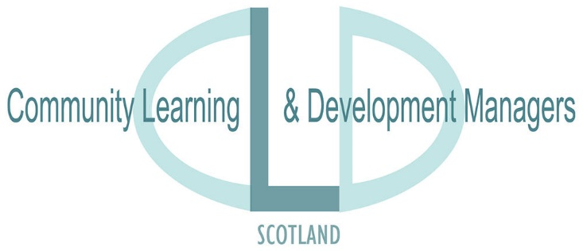
Adult Learning Subgroup
Consultation: Adult Learning Outcomes
October-December 2017.
CLDMS Adult Learning Subgroup have developed a draft set of Adult Learning Outcomes reflecting the wide range of policy drivers influencing current working practise. The expectation is that partners will find these useful in demonstrating the impact of their own work as well as developing a common language to underpin work around CLD Strategic Guidance and required partnership Action Plans.
Please consider the draft Adult Learning Outcomes and respond to the following questions:-
Key Questions:-
- Is the language and content appropriate?

- Is there anything you would change? Please give alternative wording.

- Is there anything missing? Please detail.

- How would you use the Adult Learning Outcomes?

Responses to: - Debra.Lindsay@southlanarkshire.gov.uk
Deadline: - December 8th 2017

